**LAB 4: Use of Constraint**

*CREATE DATABASE constraintlab4*

*CREATE TABLE department(*

*did int primary key,*

*dname varchar(20) NOT NULL,*

*location varchar(20) default 'head office'*

*)*

*CREATE TABLE employee(*

*eid int identity(1,1) primary key,*

*fname varchar(20) NOT NULL,*

*mname varchar(20),*

*lname varchar(20) NOT NULL,*

*Email varchar(20) unique,*

*salary decimal(10,2) check(salary >= 18000),*

*did int , foreign key(did) references department(did),*

*joindate date default getdate()*

*)*

*select\**

*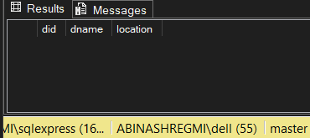from department*

*select \**

*from employee*

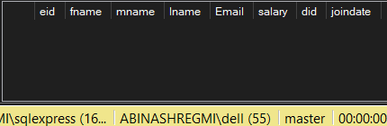

1. **Insert 10/10 valid records to each of the table**

*INSERT INTO department (did, dname, location) VALUES*

*(1, 'Human Resources', 'Kathmandu'),*

*(2, 'Finance', 'Pokhara'),*

*(3, 'IT', 'Lalitpur'),*

*(4, 'Marketing', 'Biratnagar'),*

*(5, 'Sales', 'Butwal'),*

*(6, 'Operations', 'Dharan'),*

*(7, 'Legal', 'Bhaktapur'),*

*(8, 'Research', 'Janakpur'),*

*(9, 'Customer Service', 'Nepalgunj'),*

*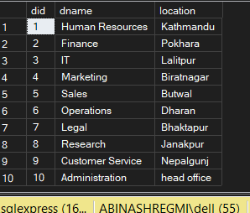(10, 'Administration', 'head office');*

*INSERT INTO employee (fname, mname, lname, Email, salary, did, joindate) VALUES*

*('Rajan', 'Kumar', 'Joshi', 'rajan.joshi@ex.com', 24000.00, 1, '2024-05-10'),*

*('Sneha', NULL, 'Tamang', 'sneha.tamang@ex.com', 22000.00, 2, '2023-10-01'),*

*('Bibek', 'Prasad', 'Shah', 'bibek.shah@ex.com', 26000.00, 3, '2022-08-15'),*

*('Laxmi', NULL, 'Malla', 'laxmi.malla@ex.com', 20000.00, 4, '2025-02-20'),*

*('Kamal', 'Raj', 'Thapa', 'kamal.thapa@ex.com', 23000.00, 3, '2023-06-30'),*

*('Nabin', NULL, 'Rai', 'nabin.rai123@ex.com', 21000.00, 6, '2024-07-12'),*

*('Pooja', 'Devi', 'Shrestha', 'pooja.shres@ex.com', 25000.00, 1, '2022-11-05'),*

*('Suman', NULL, 'Lama', 'suman.lama12@ex.com', 19500.00, 8, '2023-03-18'),*

*('Asha', 'Kumari', 'Yadav', 'asha.yadav12@ex.com', 21500.00, 9, '2024-09-25'),*

**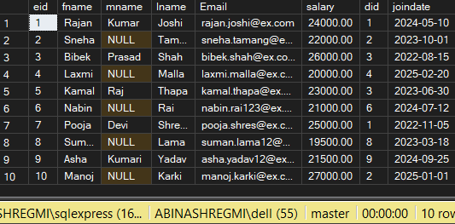***('Manoj', NULL, 'Karki', 'manoj.karki@ex.com', 27000.00, 2, '2025-01-01');*

1. **Insert any two employees of email same**

*INSERT INTO employee(fname, mname, lname, Email, salary, did)*

**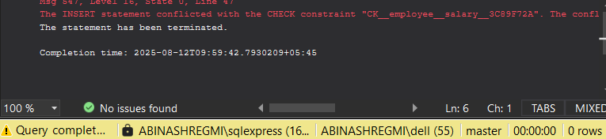***VALUES('uncle','kumar','jha','adsss@gmail.com',15000,1)*

1. **Insert any two employees without their join date**

*INSERT INTO employee(fname, mname, lname, Email, salary, did)*

*VALUES('abd','kumar','jha','abd@gmail.com',150000,1),*

**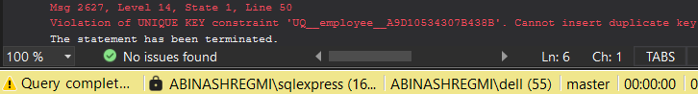***('bad','kumar','jha','abd@gmail.com',150000,1);*

1. **Find all employees of department unknown.**

*SELECT \**

*from employee e*

*LEFT JOIN department d*

*ON e.did = d.did*

**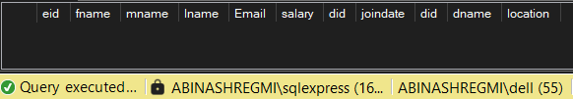***WHERE d.did IS NULL;*

1. **Delete IT department**

*DELETE from department*

*WHERE dname = 'IT'*

